Project Proposal on Online Tattoo Service

Computing Project (CP)

Level 5 Diploma in Computing

Softwarica College of IT & E-Commerce

Kathmandu, Nepal



Submitted By: Submitted To:

Name: Ashish Dongol Sudeep Bajimaya

NCCID: 00174422

Contents

Chapter 1: Introduction 4

Project Introduction 4

Justification of The Project 4

Description of The Project 4

Features of the Project 4

Overview of the Project 4

Chapter 2: Scope of the Project 5

Scope 5

Limitation 5

Aims 5

Objectives 5

Overview of the scope 5

Chapter 3: Development Methodology 6

Waterfall model 6

Design Pattern 7

Architecture: 9

Chapter 4: Work Breakdown Structure (WBS) 11

Milestones 12

Gantt Chart 13

Chapter 5: Risk Management 15

Chapter 6: Configuration Management 17

Chapter 7: Conclusion 18

References and Bibliography 19

Figure 1 Waterfall Model 7

Figure 2 MVC 8

Figure 3 Architecture 10

Figure 4 Work Breakdown Structure 11

Figure 5 Gantt Chart 13

Figure 6 Gantt Chart 2 14

Figure 7 Configuration 17

# Chapter 1: Introduction

## Project Introduction

This project **Royal Tattoo Service** is an online service where clients or customers can easily book tattoo artist for several hours and can also browse tattoo’s in the website. This system makes booking of artist’s a lot less easy as customers can easily search for that artist and they can also innovate their own design of tattoo in the website.

## Justification of The Project

In Nepal there are not many tattoo services where customers can easily buy tattoos, innovate them and book artists. Even though there are few of them customers cannot book artists properly as some have bugs while others interface design is bad and some are just not good. Some of the websites I have seen does not even work properly and booking is a bit off and have many processes to complete. So, in order to make booking a lot easier and faster I have made this project.

## Description of The Project

Royal Tattoo Service is a web-based application which will be developed with the help of PHP Object Oriented. MySQL will be used in the backend of the system. This project will be using php with a framework Laravel which helps in making online transactions and booking a lot easier that done with the object oriented. This project will be made to make online booking of tattoo artists a lot easier, buying of tattoos and even designing of tattoos a lot easier.

## Features of the Project

* Managers can update some information in their profile, can add, delete and even update artist.
* Managers and customers can upload photo in their profile.
* Customers can update their profile and can design tattoo.
* Customers can Login within the website.
* Online transaction.
* Online Booking.
* Tattoo Information.
* Generate of Invoice after completion of Transaction

## Overview of the Project

Royal Tattoo Service is a web application where users can book artists, buy tattoos from artists and also innovate their own design.

# Chapter 2: Scope of the Project

## Scope

This projects main scope deals with the online service of tattoos that are found in Nepal. This project scope is made to make online tattooing service a lot less easy and reliable to the people of Nepal.

## Limitation

Some of the limitations are:

* Internet access is needed to use this system.
* International payment cannot be done which is with Mastercard, PayPal.
* Limited to Nepal only

## Aims

* To make it easier for customers to book tattoo artists and even buy tattoos.
* Encourage customers to innovate their own tattoo.
* Provide user satisfaction while using the website.

## Objectives

* Performing of a better design.
* Making of a user-friendly system.
* Providing of detailed information about product and artists.
* To provide a robust form where customers can easily use.
* Making of booking and transaction automated.
* Enabling of importing photos of a better design of tattoo for customers.

## Overview of the scope

This project behaves as a market which gives a platform for artists where they can show their product as well as services that are in Nepal. The main aim of this system is making user a user-friendly website where they can easily book tattoo artists, buy tattoos and innovate or design their own tattoos. This can make tattoo appear in a mass market in Nepal. To make these aims possible many sets of objectives are completed.

# Chapter 3: Development Methodology

## Waterfall model

In this development methodology each phase or step must be completed before moving on towards the next phase or step. It is a very simple methodology and can be easily used. Each and every step are completed one at a time as it is a sequential approach. There are several phases in the waterfall model they are:

1. Planning

This phase includes the duration where the group discusses how the system should be made and what kind of plan we should follow.

1. Analysis

This phase includes the time where the group analyze how the system will perform in the long-term basis and how much benefit it will have.

1. Design

This phase includes the front-end part of the system i.e. the design of your system. In this phase developer design the main UI of the system containing various facility for the benefit of the users.

1. Implementation

This is the phase where the developer start coding the system so that it will fulfill what the system should do. This is the important part a single mistake can hamper the system.

1. Testing

After the system coding is completed testing is performed to check whether the system has any issues and if there are any issues then those issues are fixed before that are released.

1. Deployment and Maintenance

In this phase the product is deployed to the general public as a beta product and if the public find the product without any bug then it is deployed live. After the deployment of a product on the production environment, maintenance of the product i.e. if any issue comes up and needs to be fixed or any enhancement is to be done is taken care by the developers.



Figure Waterfall Model

Advantages of Waterfall Method

* It is easy to understand and use.
* Steps are completed one at a time.
* Each step has a particular result and a review process.
* It works well for smaller projects.

Disadvantages of Waterfall Method

* It is difficult to go back and make changes as it lacks flexibility.
* It is not suitable for large projects.
* It is not a good development method for complex and object-oriented methods.
* It cannot be used where the requirements are dynamic or change in time.

## Design Pattern

The design pattern that I have chosen for this project is Model View Controller (MVC) Design Pattern.

* Model - The model handles the business logic.
* View – It handles the representation of the elements in the user interface.
* Controller - It allows user to interact with the model. It acts as interface between the model and the view components to process all the business logic and incoming requests. It provides the ability to manipulate the system.

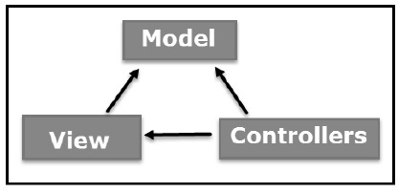

Figure MVC

Advantages of MVC:

* It helps in the rapid development of an application. Here one of the programmers can work on view while the other one can work on controller.
* There is a minimal chance of code duplication in this method as it separates data and business logic from the display
* It supports asynchronous technique which helps to develop an application that loads very fast.
* Modification does not affect the entire model because model part does not depend on the views part.

Disadvantages of MVC:

* It increases the complexity of the application.
* Multiple programmers are needed.
* Developers must have knowledge on multiple technologies.
* There is shortage of efficiency of data access in view.

The tools that I will use in this project are:

|  |  |
| --- | --- |
| Programming Paradigm | Object Oriented |
| Server Solution Stack | XAMPP |
| Modelling Tool | Visual Paradigm |
| Framework | Laravel |
| Programming language | PHP |
| Database | MySQL |

## Architecture:

For this project I have followed 3-tier architecture pattern. Three-tier architecture typically comprise a presentation tier, a business or data access tier, and a data tier. Three layers in the three-tier architecture are as follows:

1) Client layer  
 2) Business layer  
 3) Data layer

1) Client layer:

It is also called as *Presentation layer* which contains UI part of our application. This layer is used for the design purpose where data is presented to the user or input is taken from the user. For example, designing registration form which contains text box, label, button etc.

2) Business layer:

In this layer all business logic written like validation of data, calculations, data insertion etc. This acts as a interface between Client layer and Data Access Layer. This layer is also called the intermediary layer helps to make communication faster between client and data layer.

3) Data layer:

In this layer actual database is comes in the picture. Data Access Layer contains methods to connect with database and to perform insert, update, delete, get data from database based on our input data.

This architecture has few advantages and disadvantages which includes:

Advantages:

1. High performance, lightweight persistent objects
2. Scalability – Each tier can scale horizontally
3. Performance – Because the Presentation tier can cache requests, network utilization is minimized, and the load is reduced on the Application and Data tiers.
4. High degree of flexibility in deployment platform and configuration
5. Better Re-use
6. Improve Data Integrity
7. Improved Security – Client is not direct access to database.
8. Easy to maintain and modification is bit easy, won’t affect other modules
9. In three tier architecture application performance is good.

Disadvantages:

1. Increase Complexity/Effort

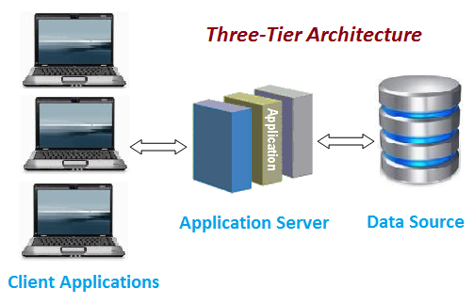

Figure Architecture

# Chapter 4: Work Breakdown Structure (WBS)

About WBS

A work breakdown structure (WBS) is a key project deliverable that organizes the team's work into manageable sections. The Project Management Body of Knowledge (PMBOK) defines the work breakdown structure as a "deliverable oriented hierarchical decomposition of the work to be executed by the project team." The work breakdown structure visually defines the scope into manageable chunks that a project team can understand, as each level of the work breakdown structure provides further definition and detail. The plan that I have followed for the project is given below:

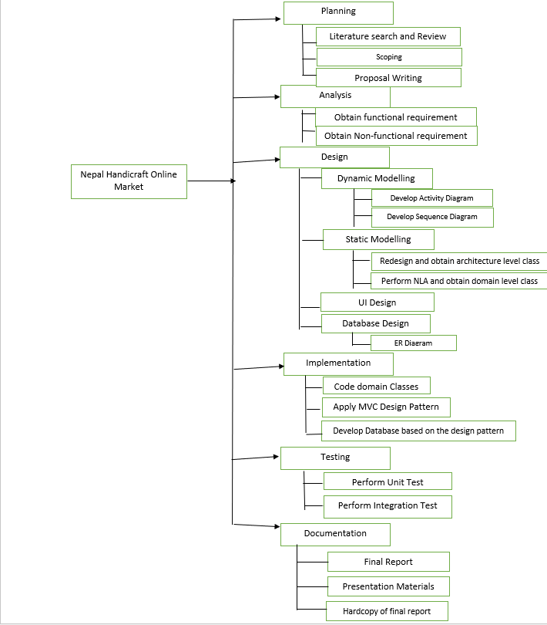

Figure Work Breakdown Structure

|  |  |  |
| --- | --- | --- |
| WBS | Task Name | Estimate Time (Days) |
| 0. | Project-Nepal Handicraft Online Market | 109 |
| 1. | **Planning** | **15** |
| 1.1. | Literature Search and Review | 3 |
| 1.2. | Scoping | 2 |
| 1.3. | Proposal Writing | 10 |
| 2. | **Analysis** | **29** |
| 2.1. | Obtain Functional Requirement | 15 |
| 2.2. | Obtain Non-functional Requirement | 14 |
| 3. | **Design** | **26** |
| 3.1. | Dynamic Modelling | 6 |
| 3.2. | Static Modelling | 5 |
| 3.3. | UI Design | 11 |
| 3.4 | DB Design | 4 |
| 4. | **Implementation** | **21** |
| 4.1. | Code Domain Classes | 6 |
| 4.2. | Apply MVC pattern | 10 |
| 4.3. | Develop Database based on Design Pattern | 5 |
| 5. | **Testing** | **7** |
| 5.1. | Perform Unit Testing | 4 |
| 5.2. | Perform Integration Testing | 3 |
| 6. | **Documentation** | **11** |
| 6.1 | Final Report | 5 |
| 6.2. | Presentation Materials | 4 |
| 6.3. | Hardcopy of final report | 2 |

## Milestones

Milestones are used in project management to some of the specific date on the project timeline. This focuses mostly on the progress points of the project that must be reached on that specific date to obtain success.

|  |  |  |
| --- | --- | --- |
| Topic | Start Date | Deadline |
| Proposal | 26th March 2019 | 9th April 2019 |
| Literature Search and Review | 26th March 2019 | 28th March 2019 |
| Scoping | 29th March 2019 | 30th March 2019 |
| Proposal Writing | 31th March 2019 | 9th April 2019 |
| Analysis | 10th April 2019 | 8th May 2019 |
| Obtain Functional Requirement | 10th April 2019 | 24th April 2019 |
| Obtain Non-functional Requirement | 25th April 2019 | 8th May 2019 |
| Design | 9th May 2019 | 3rd June 2019 |
| Dynamic Modelling | 9th May 2019 | 14th May 2019 |
| Static Modelling | 15th May 2019 | 19th May 2019 |
| UI Design | 20th May 2019 | 30th May 2019 |
| DB Design | 31th May 2019 | 3rd June 2019 |
| Implementation (Coding) | 4th June 2019 | 24th June 2019 |
| Code Domain Classes | 4th June 2019 | 9th June 2019 |
| Apply MVC pattern | 10th June 2019 | 19th June 2019 |
| Develop Database based on Design Pattern | 20th June 2019 | 24th June 2019 |
| Testing | 25th June 2019 | 1st July 2019 |
| Perform Unit Testing | 25th June 2019 | 28th June 2019 |
| Perform Integration Testing | 29th June2019 | 1st July 2019 |
| Final Doc | 2nd July 2019 | 12th July 2019 |
| Final Report | 2nd July 2019 | 6th July 2019 |
| Presentation Materials | 7th July 2019 | 10th July 2019 |
| Hardcopy of final report | 11th July 2019 | 12th July 2019 |

## Gantt Chart

## 

Figure Gantt Chart

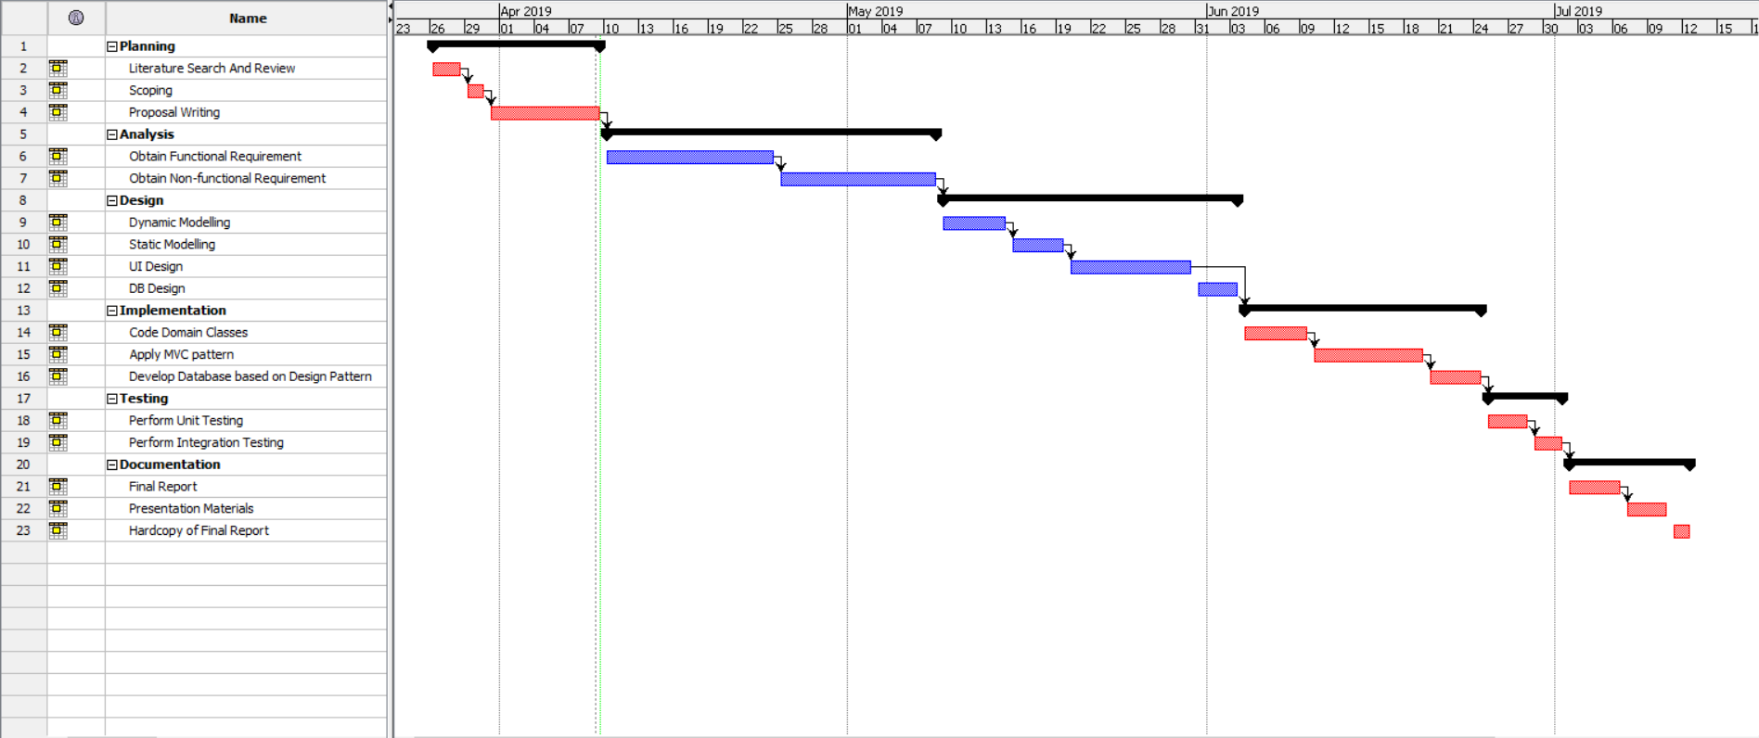

Figure Gantt Chart 2

# Chapter 5: Risk Management

Risk Management is simply identification and evaluation of risks. Risks may rise from anywhere which can interrupt the normal flow of work within the system. In order to track those risks a proper guideline must be prepared.

For the risk management its most to find the risks that can damage the system. The steps that we can follow for risk management are:

1. Identify risk
2. Access impact of risk
3. Alleviate critical risk
4. Control risk

|  |  |
| --- | --- |
| **Likelihood** | **Value** |
| Low | 1 |
| Medium | 2 |
| High | 3 |

|  |  |
| --- | --- |
| **Consequence** | **Value** |
| Very low | 1 |
| Low | 2 |
| Medium | 3 |
| High | 4 |
| Very high | 5 |

Taking this value, we can calculate the risk management as Impact = Likelihood x Consequences

|  |  |  |  |  |
| --- | --- | --- | --- | --- |
| **Risk** | **Likelihood** | **Consequence** | **Impact** | **Action** |
| Degrade of performance due to hardware. | 2 | 4 | 8 | Upgrading of hardware for better performance. |
| Natural Disasters | 1 | 5 | 5 | Backing up of data at a regular basis. |
| Hard Disk Crash | 1 | 4 | 4 | Cloud Back Up should be done. |
| Infected by Virus | 2 | 4 | 8 | Installation of genuine anti-virus. |
| Requirement Changes | 2 | 5 | 10 | Client should be contacted regularly |
| Software Bugs | 2 | 4 | 8 | Releasing of patches to solve bugs |
| Imprecise estimation | 2 | 3 | 6 | Finishing of all the tasks at the right time. |

Here are some of the precautions that can be used on risks that have a high impact of the software.

1. Performance Degrade:

Performance degrade in a system is mostly due to old hardware which cannot handle all the load of the application. So, to prevent it there are following measures:

* Upgrading of hardware annually if needed.
* Cleaning of dust particles from the hardware as it might help in the performance.

1. Virus:

Virus in a system is a type of contagious software which makes copies of itself and exploits security vulnerabilities. So, to prevent it there are following measures:

* Using of a genuine Anti-Virus Software
* Updating of Anti-Virus on a daily basis.
* Scanning of the System on a daily basis.

1. Software Bugs:

Bugs in a system is a type of error, flaw or failure which causes the system to produce an incorrect result of the given input. So, to prevent it there are following measures:

* Patching or updating of software to fix bugs.
* Proper Testing of the software before deployment.

# Chapter 6: Configuration Management

Configuration Management is simply tracking of changes done within the software. This project is based on (SDLC) Software Development Life Cycle or Waterfall Model. Here each and every phase has its own folder which contains its own files. The final project directory is:

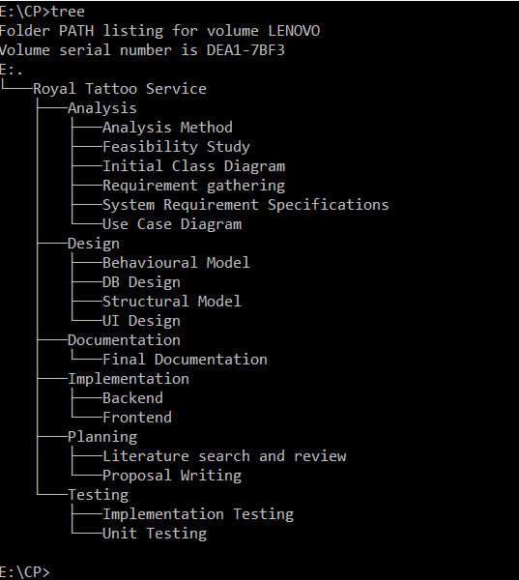

Figure Configuration

# Chapter 7: Conclusion

Royal Tattoo Service is an online service or platform based in Nepal. There are many features such as artists can sell their products in the website, made themselves available for booking for customers and most importantly customers can innovate their own kind of design by giving their own description, photo etc. To make this application possible I have used PHP and MYSQL. I have also used Laravel framework which makes the coding much easier. For this system I have used the waterfall model and used (MVC) Model View Controller Design Pattern and three-tier architecture. Risk management is done thoroughly and precautions are used according to the risks. There are many risks in the system but some have high impact on the system. These risks are given precautions accordingly. This project configuration is done properly with every phase shown in the diagram. Each Phase has its own folder with its own sub folders. This project is also backup every 2-3 days for data security. Each and every data stored in the system is stored in database and also backup in cloud. In this way this project will be made to give a platform for both artists and customers.

# References and Bibliography

1. Rahman, S. (2016). *Design pattern: Obligation link design pattern*. Beaumont, TX: Lamar University.
2. Siegel, J. G., & Shim, J. K. (2003). *The managers handbook of client/server computing in business and finance*. Mason, OH: Thomson/South-Western.
3. Metsker, S. J. (2002). *Design patterns Java workbook*. Boston: Addison-Wesley.